Random Loads and Processes D

longer learning diary

For this course, I think there are some points that I could write in this longer learning diary. At first, let me introduce what I have done and why I should do those tasks. Honestly, I have attended all the lectures that Jani hosted and from which it gives me some basic knowledge of random load process from evaluation of short-term and long-term probability distribution of road profile to realization of achievement of road profile and response.

In the first week, I have learnt some basic concepts about random load process in a big picture, such as application situation, characteristic of circumstance, loads in time domain and response in frequency domain with RAO (response amplitude operator), design criteria and etc. Apart from that, cumulative probability distribution (CDF) and probability density distribution (PDF). Along the PDF, I also learnt its properties, such as linear operations (addition, multiplication). Additionally, using frequency to represent the probability is another point, which we later also referred. Then some fit function is introduced, such as scatter(data), polyfit-function, cdf-function. When it comes to the numerical process, using limited estimated data that has a tail is enough, especially in our model, the long-term process is quite same as 95% operating process and we hardly omit some events, such as black swans. Other points such as variance and autocorrelation also are applied in later assignments, especially in assignment 4, but most of them are computed in MATLAB after numerical definition. Finally, they are hints which we have used in assignment five that are the random process is subordinated to Weibull distribution when it comes to long-term process; it is subordinated to Rayleigh distribution, when it comes to short-term distribution of wave height; it is subordinated to normal distribution when it comes to wave elevation over the time. The assignment is related to finding a model and its definition of measurements with sensors, simulation, and definition of probability distribution from corresponding literatures.

For finding the probability distribution, I did not understand the question that required us to do what we should do and what is the short-term and what is the long-term. Until I find the article where it defines the short-term and long-term probability distribution with different ways and the criterion is distance.

When it comes to assignments, what I have done mainly includes getting short-term expected probability distribution, its reasoning and what the probability distribution is closed to. Actually, we defined our load in road profile and our model with semi-active suspension system through searching the article [3] or something else. In the model we further define adjustable damper, suspension spring and connected spring(tyre), body and wheel, could have a better consideration in cost and realization of stability, the random road profile, which is explained with data for its fluctuation in vertical direction. We adopt some sensors, such as accelerometer, displacement sensor, and tilt angle sensor. In order to apply these measured dynamic responses, we could build a system with measurement of vertical displacement of road profile as input and get the vertical displacement of vehicle’s body as output. Finally, with the fitted data in article, in short-term probability distribution, gaussian distribution is matched in our model as well as in long-term probability distribution, rayleigh distribution is matched[1][2].

From the RLP1-Design Process, i think the biggest achievement is i understand the whole design process from finding a engineering problem to simplification of the problem, to the definition of RAO and to final system’s response and long-term fatigue. According to lecture’s design process, we find semi-active suspension system, sensors we should use to acquire vertical displacement as well as accelerometer to acquire accelerations and find fitted data with RMS(root mean square)-level which match rayleigh distribution.

For the short-term distribution, it is

$$f(x)=\frac{1}{σ\sqrt{2π}}e^{{-(x-μ)}^{2}/2σ^{2}} (1)$$

$$P(x)=\frac{1}{σ\sqrt{2π}}\int_{-∞}^{x}{e^{{-(x-μ)}^{2}/2σ^{2}}dx} (2)$$

where $σ^{2}$ is variance and μ is mean value.

For long-term probability distribution, it is

$$P(x)=\left\{\begin{aligned}\frac{2(x-∅)e^{-\frac{x-∅}{σ^{2}}}}{σ^{2}}, for x≥∅ \\ 0, for x<∅\end{aligned}\right. (3)$$

where P(x) = probability of the signal at RMS level x; x =RMS level.

Additionally, the following parameters should be made use of to explain the relevance of distribution and road profiles. [2]

* Moving RMS (root-mean square value) road surface elevation
* Moving crest factor
* Spectral characteristics
* Road surface elevation probability distribution characteristics (kurtosis statistics)
* Fluctuation amplitudes distribution characteristics (standard deviation of fluctuation amplitudes)
* Characteristics of transients (joint distribution of amplitude and duration)

Those relevant factors are quite important and i think they will be used in the next discussion. Here we get the rayleigh distribution with x(elevation displacement per m^2) and y(occurance equal to probability). We first found the article[1], but there is no equations to define what the probability distribution is with fitted data. So we further find the author, who had did many researches in probability distribution of road profile, and try to find some articles to acquire the equation of long-term process. It is searching process that the article[2] was found in which the formula of Rayleigh distribution is provided. However, i didn’t understand the relation with RMS and occurance. Actually, from my opinion, there are figures or equations directly describing the relation between vertical displacement of road profile and probability either in short-term process or in long-term process. What i should do more to understand in those articles is to make sense the assumptions mathematic conditions before using simplication of semi-active suspension system. Secondly, how to compute those defined features, such as mean value, variance, RMS, maximum/minimum, standard deviation and etc.

I think i should apply those theory into practice in MATLAB to understand those better and how to write scripts in MATLAB with some algorithm and data is key point to get some findings. The last point i should mention is that sometimes i have found the correct article to acquire data, but i didn’t notice enough to ignore the valuable articles.

In the second week, I have learnt single-degree-of-freedom linear system with viscos damping and harmonic excitation force including stationary or steady state situation and types of responses. With the effect of harmonic excitation, the response consists of two main parts that are decaying transient part and steady state part, but with time going by the transient part will gradually disappear, and the system tends to keep steady state. Here, one situation is used in the process of random load as assumption, which is steady state, so the situation in the beginning process is ignored and under this circumstance, the system keeps stationary. For the response, I paid more attention on damping response which could be used in our model. With effect of resonance, we could get response spectrum with input of excitation spectrum. In the next stage, some practical skills about how to use MATLAB are introduced, such as Fast Fourier Transform (FFT) and inverse process (IFFT), narrow band as well as broad band and with window function to filter disturbance, creating freak event by matching common phase. With FFT, signals can be clearly decomposed in frequency domain. During this week, I have confronted some questions that I didn’t understand at that time, such as difference between narrow banded process as well as random banded process which directly I didn’t create broad band wave at the beginning. Additionally, I also didn’t understand the concept of window function before searching some websites and articles. Currently, I think there is an obvious difference between bands and for narrow band it is simple to make a distinction between signals in time domain. Also, the interval of frequency in frequency domain is larger than in time domain. Instead, for broad band, it is difficult to differentiate mixed signals and the signals seems continuous at the same level. As for window function, it is used to filter noise signals and only capture central signal source and then expand this signal to horizontal axis.

So, the main topics in this week is related to:

* DoF system and its analysis with transient part and stationary part;
* Influence of different parameters (damping coefficient, mass);
* Over- and under-critical structures, Dynamic, Quasi-static and resonance response;
* Practical skills with MATLAB such as how to use FFT.

Here, some points are related our model that are transient part is friction or dump or bulk in the road, and the stationary section is represented as road surface without considerable defects.

In the assignment, there are some points that have been put forward in the lecture, such as harmonic excitation and transient part and stationary part in semi-active suspension system. The following figure is stationary part for 1-DOF m-c-k system.

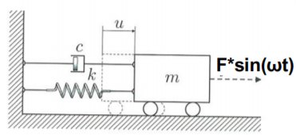

Figure A simple 1-DoF spring damper mass system

Its equation is as follows,

$$m\ddot{u}+c\dot{u}+ku=Fsin(ωt) (4)$$

m is mass;

k is stiffness;

c is coefficient of damping;

$Fsin(ωt)$ harmonic force excitation to the system;

$ω$ is oscillation frequency;

F is acitve force;

u is displacement, $\dot{u}$ is first order derivative, $\ddot{u}$ is second order derivative

the beforehand equation is stationary, but when the transient part is considered, the formula is as follows,

$$μ\left(t\right)+μ_{p}\left(t\right)=e^{-ξω_{e}t}\left(a_{1}cos\left(ω_{d}t\right)+a2sin\left(ω_{d}t\right)\right)+asin\left(ωt-φ\right) （5）$$

$$ω_{d}=ω_{e}\sqrt{1-ξ^{2}} （6）$$

t is time;

$μ(t)$ is the signal of transient part;

$μ_{p}(t)$ is the signal of stationary part;

ξ viscous damping ratio;

$ω_{e}$ is eigen frequency of the system;

$ω_{d}$ is the frequency of transient part;

$ω$ is the current frequency of stationary part;

a1 is one of the amplitude of transient part; a2 is the another amplitude of transient part;

a is the amplitude of motion of stationary part;

$φ$ is phase angle;

When we have created our model of in MATLAB and there are two figures, one is amplitude of 1-DOF in time domain including transient part and stationary part, the another is amplitude with FFT in frequency domain.

Figure amplidtude of 1-DOF in time domain

So we can see that at first, the amplitude is larger than 1, because there is transient part, and some time later, the signal is in steady process, and the amplitude is same with right figure either in time domain or in frequency domain.

When it comes to the FFT, we also could deal with multiple signals from time domain to frequency domain to clearly decompose them. With the aid of FFT, those extra disturbance with their amplitudes and a series of frequencies can also be clearly drawn at the bottom of horizontal axis. For narrow banded process(Figure 3) and broad banded process(Figure 4), in time domain, narrow band can be clearly distinguished and all frequencies are in narrow frequency band; instead, broad band is in a mess when signals are mixed with different frequencies. It is difficult to ensure zero mean as it varies over long time. In frequency domain, narrow band have Larger interval (0-25Hz) in frequency domain and broad band has smaller interval(0-100Hz) which causes some signals difficult to capture. The following figures have validated the description.

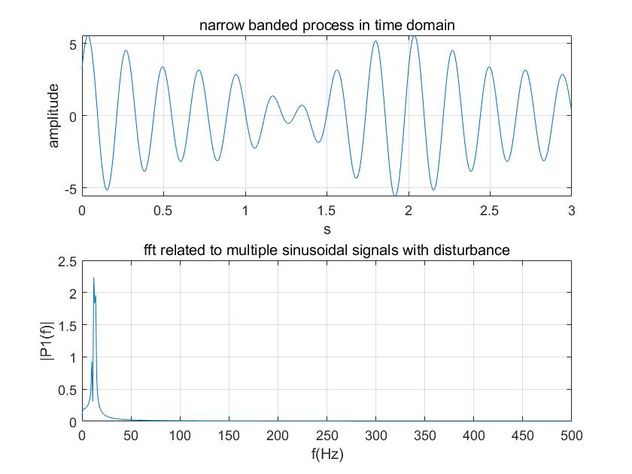 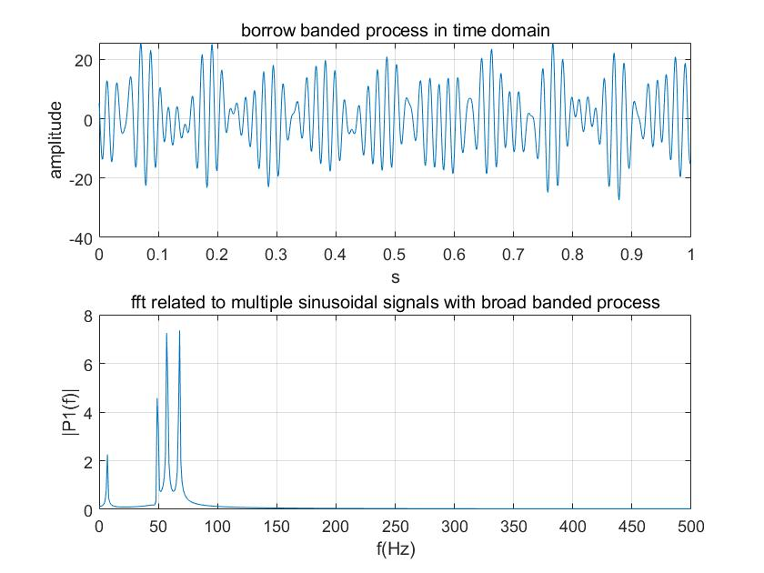

Figure narrow banded process Figure broad banded process

Window function can help us filter signals with leakage to other period which causes an effect of addition, and therefore it can ensure that only limited signal within the original bandwidth is captured. In Figure 5, we can see that signal with disturbance is more clear in higher amplitude, though there are some burrs still existed. Anyway, the signal is distributed between 0-20 Hz,

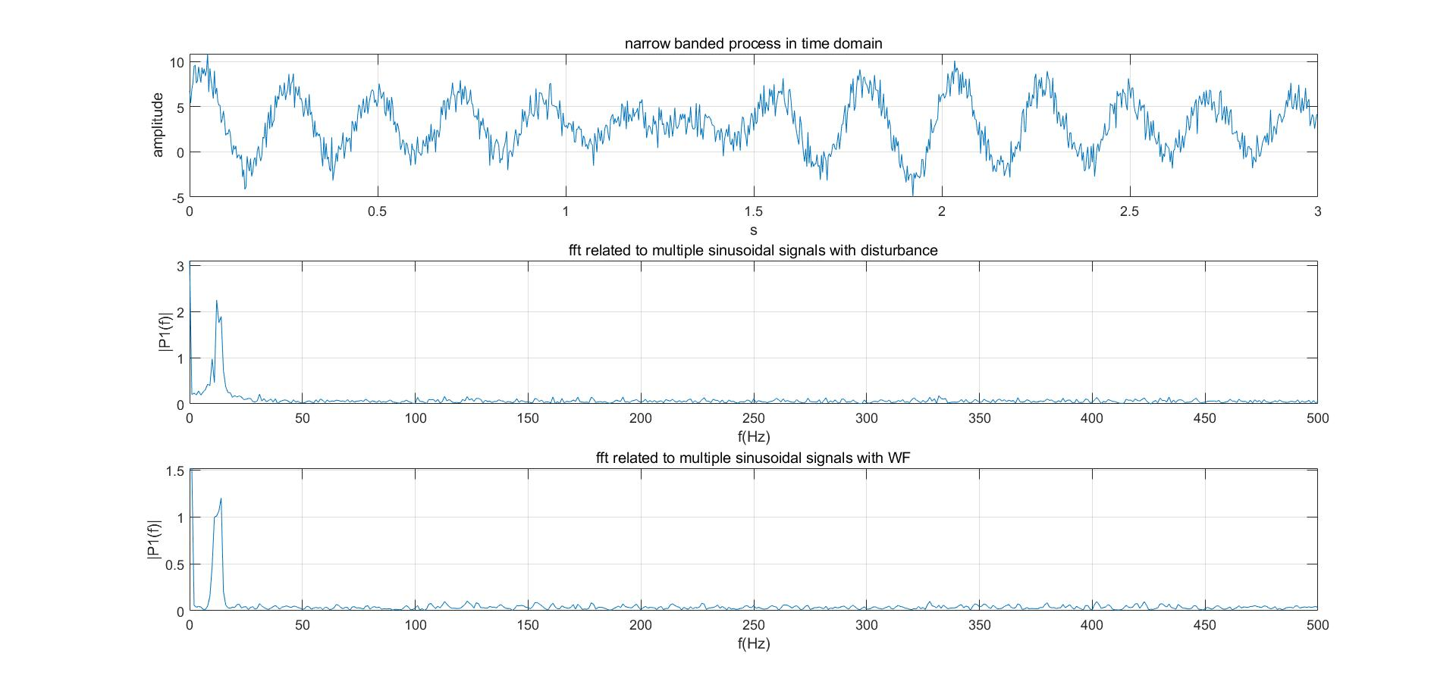

Figure narrow banded process and its effect with Window Function

In comparison with narrow band, broad banded process has an obvious effect with window function. Signals are limited to small range of frequencies.

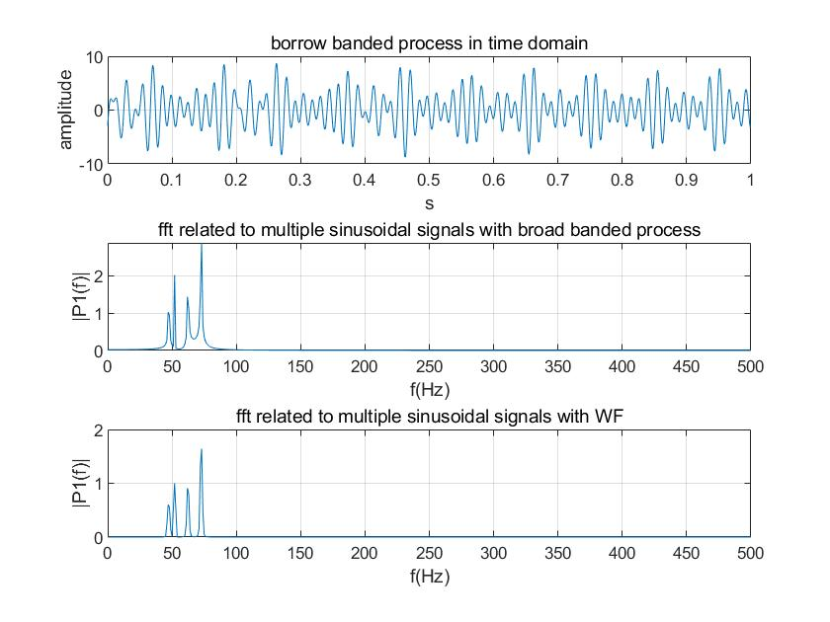

Figure broad banded process and its effect with Window Function

Finally, there are many applications for huge amplitude in waves, especially those focusing wave, such as artificial wave in pools, estimation of ocean wave effect. Based on these application, in order to analyze, freak event in waves are created to estimate this effect, which seems like an abnormal peak value, when many sinusoidal spectrums accelerate together in a moment, such as 10 or 15 signal sources disseminate along an axis. Depend on the difference of phase, those spectra will create the effectiveness of addition and odd kurtosis, but it will be created by the characteristics of spectrum [1][4].

In this week, two articles I have read for understand the process of freak event of wave as well as roles of time and frequency domain during design process. By reading articles, I have understood the occurrence of freak event and these probabilities are directly related to the occurrence of freak waves. At that time, I also didn’t understand the concept of latching control, so through the discussion and read another article as well as further analysis of primary article, the problem of comprehension of that which is solve. There is one application of latching control in time domain. we shall assume that amplitudes of waves and oscillations are sufficiently small enough, and they could be ignored with the continuous time, which could cause some points lost in time domain at one situation, the system is not time invariant and it is used to achieve the same phase in a system with the loading of the system in which the time possibly is variant.

In third week, jani in lectures has spent effort explaining the concept about how to draw the histogram and curve with polyfit, such as typical variance spectrum of waves when using data that are observed percentage frequency of occurrence of wave heights and period. It seems matching the horizontal axis and vertical axis with wave height and period when using rainflow to analyse data with stress range(fatigue) and its cycle. Under my own comprehension, I also understood its concept and how to draw the histogram or polyfit with tabular data. Apart from that, a series of waves are introduced, such as ocean wave, wind wave as well as ice loads, etc. However, road profile is given when the road is built for our model, that is

$$S_{xx}\left(Ω\right)=CΩ^{-w} (7)$$

$Ω$ is the angular spatial frequency/[rad/m], Ω=2π/L;

L is wavelength;

C is unevenness index;

w is waviness;

Here, we define the road is stationary, so parameters are set as follows.

The mean value for C chosen as 0.336 [10^-6 rad m];

The waviness ranges from 1.5 to 3.5 with the most typical value as w = 2;

ISO 8608 wavelengths ranges from wavelength band 0.3054 m to 90.9 m or spatial frequency ranges 0.011 cycles/m to 2.83 cycles/m(here, the wavelength or the frequency ranges is based on overall wavelength)

I think, this week’s lecture is a transmission of our model from from theory into practical after getting road spectrum, from basic concepts to deeper knowledge, such as analysing response of sprung mass with the help of simplified mathematic model. In the assignment, I have arraged the computation of mathematic model of semi-active suspension system, but here the coefficient set as a constant instead of a variable. Actually, considering the comfort in the long-term travelling, the coefficient of viscos damping should be set as a variable, so that we can modify the amplitude under a series of frequencies to further accommodate the feeling of comfort.

Along the research of last week, we assumes that the phase component of a signal is random and uniformly distributed, that the process has a Gaussian distribution, and that it is stationary (Le.,devoid of transients). Therefore, we define our circumstance under steady state in the process of normal situation without the presence of spurious and transient phenomena such as potholes and other major road surface defects. These factors are not taken into account by superposition of the actual dimensions of the "defects" onto steady-state signals[1]. On the one hand, it is convenient to compute or to acquire experiment data when without taking some parameters int consideration and there is no need to add specific transducers, but these tend to oversimplify the characteristics of the process. Disadvantages are listed as follows:

* PSD functions are usually obtained from measurements of accelerations of a vehicle loading tray during transit. However, due to the large number of uncontrolled parameters such as vehicle suspension characteristics, payload, and road roughness. The process of measuring and analyzing acceleration records must be undertaken and repeated for any combination of the aforementioned parameters[1]. that is to say, the stationary acceleration is regarded as the measured value;
* variations of parameters are not taken into consideration, such as vehicle velocity and transient accelerations appeared in one journey;
* The unsprung mass is not set as a constant, in case where masses are changed with a large range.

So, in the fourth week, some further assumptions are set. When the accelerations are set as subordinated to gaussian distribution. Further, in 1999, authors, such as Bruscella, B., Rouillard validated this idea when they first put forward that assumption in 1996 in article “Analysis and Simulation of Road Profiles”.

In 1999, Bruscella and Rouillard also put forward Rayleigh distribution with measured data in smooth road and rough road. In 1996, they have put Rayleigh distribution in three different road which are smooth road, moderate road and rough road. But at that time, the vertical axis is distribution of fluctuation amplitudes (relatively additive displacement), and it is not very clear to distinguish from road surface elevation (absolute displacement, relative to horizontal axis) in compared with RMS analysis method.

In this part more assumptions are set to further define the problem, such as no friction, no horizontal displacement, constant mass of the whole quarter car, and so on. After taking the analysis of the article 3 as well as with the help of sofia’s work, I also found four new assumptions in a website which lost the title, the author’s name, the data and something else that could comprehensively depict them well. They are:

* Quarter vehicle are regarded as a whole part in the process of motion;
* Driving the vehicle in a constant velocity and only take into account a vertical direction;
* The sprung mass is set as a constant value;
* Uneven road surface and road irregularities are the unique factor to be responsible for the vibration transfer in vertical direction.

Based on what i learnt and what the assumptions have made, the simplified mathematic model can be put forward.

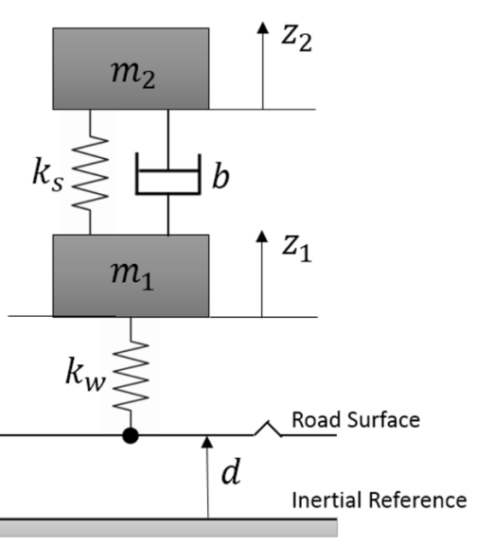

Figure Car suspension system

From the Figure 7, the dynamic equations of the model are given by:

$$m_{2}\ddot{z_{2}}+k_{s}\left(z2-z1\right)+b\left(\dot{z_{2}}-\dot{z_{1}}\right)=0 (8)$$

* ks – suspension stiffness
* kw – tyre stiffness
* b– suspension damping coefficient
* m1 – un-sprung mass
* m2 – sprung mass
* d– distance between road profile and inertial reference constants
* z1 – displacement of the unsprung mass
* z2 – displacement of the sprung mass

and then set the state-space formula:

$$\dot{X}=\left[\begin{matrix}\begin{matrix}0 & 1 \\ -\frac{k_{w}+k_{s}}{m_{1}} & -\frac{b}{m_{1}}\end{matrix} & \begin{matrix}0 & 0 \\ \frac{k_{s}}{m_{1}} & \frac{b}{m_{1}}\end{matrix} \\ \begin{matrix}0 & 0 \\ \frac{k_{s}}{m_{2}} & \frac{b}{m_{2}}\end{matrix} & \begin{matrix}0 & 1 \\ -\frac{k_{s}}{m_{2}} & -\frac{b}{m_{2}}\end{matrix}\end{matrix}\right]X+\left[\begin{matrix}0 \\ \frac{k_{w}}{m_{1}} \\ \begin{matrix}0 \\ 0\end{matrix}\end{matrix}\right]*U (9)$$

$$Y=\left[\begin{matrix}\begin{matrix}\begin{matrix}1 \\ 0\end{matrix} & \begin{matrix}0 \\ 0\end{matrix}\end{matrix} & \begin{matrix}\begin{matrix}0 \\ 1\end{matrix} & \begin{matrix}0 \\ 0\end{matrix}\end{matrix}\end{matrix}\right]X+\left[\begin{matrix}0 \\ 0\end{matrix}\right]*U (10)$$

$$X={[z1,\dot{z_{1}},z2,\dot{z_{2}}]}^{T},U=d=S_{xx}, Y={[z1,z2] }^{T}$$

And get the transfer function which is H(w) and using formula 11 below calculate response for random loading:

$$S_{yy} ={|H(w)|}^{2} *S_{xx} {=|H(w)|}^{2}*{CΩ}^{-w} (11)$$

$$F=\frac{71430 s + 1429000}{s^{4}+\frac{5143}{100}s^{3}+51030s^{2}+71430s+1429000} (12)$$

$Syy$ is response spectrum;

$|H(w)|=F$, ${|H(w)|}^{2}$ is RAO;

$Sxx$ is loading spectrum.

After input the concrete values:

* m1=10;
* m2=350;
* kw=500000;
* ks=10000;
* b=500.

The value of the following figures, which are RAO and the response of load spectrum, can be computed. After that, we can get the figure of Response of the system for random loading shown as Figure 8, which is narrow band since the signal is in a smaller frequency interval.

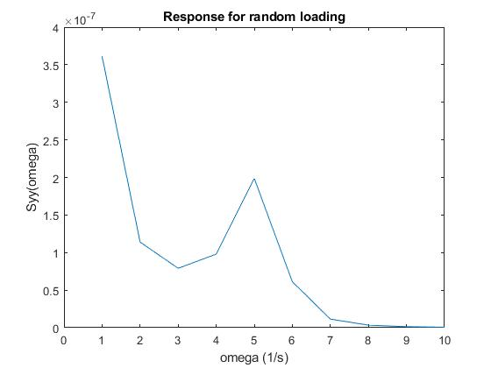

Figure response of the system for random loading

As for the transformation of types of band, there is one article which has validated that the type road band can be transformed to narrow band by decreasing the signals sampled from transducers. Additionally, through referring to literatures, the formation of narrow band is normally created by superposition of several short bands from sensors. That is to say, if we want to get a narrow-banded signal, we can do the reverse computation. In articles, researchers put forward some algorithms to get the broad band when a series of narrow bands are provided. Because of the linearized correlation among signals, a reliable method to get narrow band is that using the final value of broad band to filter some irrelevant frequencies, a band with low frequency can be computed to meet the requirement. Honestly, there are few literatures depicting the direct process from narrow band to broad band, so it also confused me at that time, so i made an assumption through linearized relation between signals since its reverse process has been validated in the article ”Narrowband to broadband conversions of land surface albedo I”.

There is one point i forget which is power spectrum density(PSD) and we also use it in fourth week and fifth week to analyse distribution in the long-term travelling process. With the help of PSD, the spectral energy distribution per unit time can be computed and it is limited although the total energy of a signal over all time would generally be infinite.

In fourth week, in order to understand what’s the circumstance related our engineering model, i have read a book of marine engineering published by Eindhoven university of Technology, which describes some details about ergodic stochastic process, although it is not directly related to the final result. Actually, assumptions should answer how we get RAO from semi-active suspension system or quarter semi-active suspension system, and what should be further simplified prior to one assumption set which is stationary process in the process of whole travelling.

When the assumptions have defined, I think our circumstance should be defined under steady state, which could be associated with stochastic process or more specifically ergodic stochastic process.

When we can define our problem that belongs to the field of iterative process of waviness, noise signals caused by transient parts such as potholes, hollows and cavities are ignored, and the attention is paid to the roughness of smooth or moderate road surface, which is the deterministic factor to our system’s response. It has been proven on the last century that it is effective to make these assumptions and further do experiments.

Then, the emphasis is put on the analysis of spectrum characteristics and computation, such as mean value, standard deviation, autocorrelation, but all of them used to be analysed in MATLAB with the numerical form.

When it comes to cumulative distribution function(cdf), the method of statistic frequency is used to represent the concrete probability, which do not know in reality or in estimation. The total equation can be expressed as follows,

$$P_{x}=\frac{M}{N} (13)$$

$P_{x}$ is frequency in certain wave height;

M are Points above certain wave height;

N are All points;

And why we could use frequency to represent probability, i think it should be ascribed to Bernoullin law of large numbers, which describes the frequency of M is infinitely tends to its probability in one experiment when every process is independent and duplicate. In assignment, using numerical method to create points and to count can help us acquire the value M and N.

By forward difference method, we know pdf is the derivative of cdf, since these points are numerical and they can be infinitely similar when the density of these interpolation point are large enough.

$$k_{i}=\frac{dy}{dx}≈\frac{∆y}{∆x}=\frac{y_{n}-y_{n-1}}{x_{n}-x_{n-1}} (14)$$

$k_{i}$ is slope in random point;

$∆y$ is the difference of probability between two continuous points;

$∆x$ is the difference of wave height between two continuous points, as for our project it is the difference of road elevations;

$y_{n}$ is the probability at one random point;

$x_{n}$ is the wave height at one random point, as for our project it is road elevation.

As for the function of mean value, standard deviation and autocorrelation, I think they can help us to validate reliability of stochastic process and in the assignment, it can been seen that mean value and deviation of loading process have slight fluctuation in time averages. Instead, mean value and standard deviation of response of the suspension system have larger changes during time sequences. These results suggest that the random loading is a relatively stochastic process and the response of system is not a pure stochastic process. I think the reason can be ascribed to those assumptions we set and those conditions we simplify.

From the angle of autocorrelation, either in loading process or in response process with each other, it is shown that at some period, the value of autocorrelation fluctuates over zero and slowly changes with time going by. Its value of road loading is smaller than system response and it mentions again that the process of road loading is more stochastic than the process of system response.

Additionally, we also fit the curve with estimated data, and the gaussian distribution is plotted with variable of road elevation (in system response only partial data in stationary state expressed by normal distribution). Actually, what is the best method to express the probability distribution? From the fit of our data in assignment, the optimal method is normal to fit the curve. It is because we do not know the exact order of equation and there is more or less redundancy or exceedance of degree. However, we can increase the interpolation points to minimize the error even with poly function to fit the curve. The compared effect can be seen as Figure 10, Figure 10.Figure 10

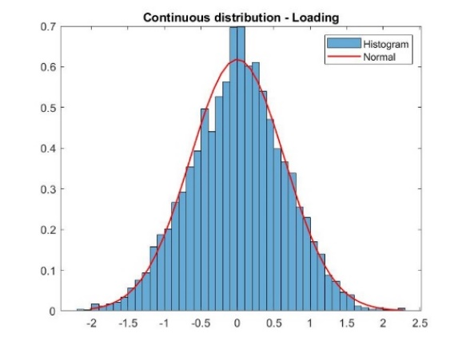 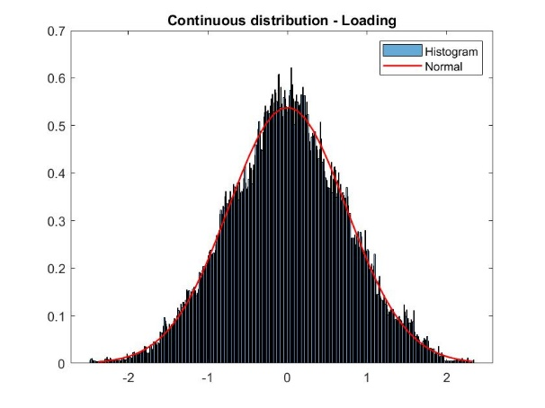

Figure 9 Rayleigh distribution with little interpolation points in Rainflow cycle counting

Figure 10 Rayleigh distribution with adequate interpolation points in Rainflow cycle counting

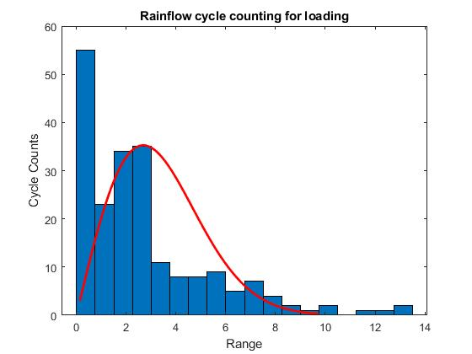

Figure Rayleigh distribution with interpolation points in Rainflow cycle counting for loading

Rainflow analysis method is used to count fatigue cycles with stress reversals from a time history and to assess the fatigue life of a structure subject in complicated loading. Figure 9Figure 10 are plotted Rainflow cycle counting for the random load signal. This is obvious because rainflow analysis counts cycles in the certain range from the signal history and we are assuming the load spectrum of the road profile analytically as exponential function [5]. Further, road roughness is the unique factor taken into consideration and thus our assumptions are reasonable. We can image that when we drive on the road, the main elevation is road elevation but not those sudden bumps.

In final week, we mainly learnt the concepts of fatigue, distribution of peaks and short-term and long-term probability distribution. In the assignment, along the analysis of week4, the analysis method of Rainflow is applied to get the Rayleigh distribution. For the most of contents, such as codes, theory, mathematic model, we have discussed on previous week. So, we understood what to do in long-term road profile, how to get the probability distribution of peak value in various road situations. Apart from that, we also define the comfort and fatigue, which is totally different from other groups, it’s much interesting, from those steel or metal buckle or something else. The fatigue here is more related to a feeling of comfort when travelling. Finally, the correlation of probability distribution between road profile and those peak values either in short-term or long-term is discussed.

From the introduction of jani’s feedback, we define our fatigue as driver’s and passengers’ comfort in travelling. The main sources of discomfort are oscillations which reach the vehicle’s passenger compartment and cause noise, vibration or both [1].

For short-term estimation of probability distribution, we use every extreme value and then fit the curve. For the formula, it is,

$$\overline{z}=\sqrt{2ln(\frac{T}{2π}{(60)}^{2}\sqrt{\frac{m_{2}}{m_{0}}})\sqrt{m_{0}}} (15)$$

$\overline{z}$ is mean extreme value;

T is time history of one period;

$m_{0}$ is the mean value of square of system response elevation;

$$m_{0}=σ_{y}^{2}=E[y^{2}]=\int_{-∞}^{∞}{S_{yy}(ω)dω} (16)$$

$S_{yy}$ is response amplitude;

$ω$ is frequency of system;

$m_{2}$ is the mean value of square of first order derivation of system response elevation;

$$m_{2}=σ_{\dot{y}}^{2}=E[{\dot{y}}^{2}]=\int_{-∞}^{∞}{ω^{2}S_{yy}(ω)dω} (17)$$

Here, we assume that our process is ergodic so that we can only pick up one signal in time history and do the analysis of histogram. Otherwise, this process can not continuously be done because gaussian distribution has the independent property. When the road profile is different in a series of sites, the peak value will also change according to road profiles.

For the long-term estimation of probability distribution, we capture 95% confidence interval since more data seems inessential and this case does not include the “black swan”. Therefore, the peak defined is also only available on 95% of the time history. Additionally, we should take into account other road type in our case. So we use formula (7) again and define the surface unevenness index for different road types, such as unevenness index in table 1.

Table 1. Surface unevenness index for different road types, C [5]

|  |  |
| --- | --- |
| **Road type** | **Unevenness index, C * 10^(-6)** |
| Motorways | 0.011 |
| Pavement type 1 | 0.336 |
| Pavement type 2 (39500 3 OH) | 0.21 |
| Driveway (17585 4 IL) | 0.927 |

According to table1, we can also get different Rainflow cycle counting for loading and response, and do the analysis in MATLAB, there are other results of cycles as well as vertical elevations. The table2 is a simplified probability of some roads used in finland.

**Table 2.** Estimations for probabilities for different road types in Finland (own experience).

|  |  |
| --- | --- |
| **Road type** | **Probability** |
| Motorways | 0.6 / 60% |
| Pavement type 1 | 0.2 / 20% |
| Pavement type 2 (39500 3 OH) | 0.15 / 15% |
| Driveway (17585 4 IL) | 0.05 / 5% |

Then in summary, when we get all of data computed, we can draw a table3 to describe the Maximum value estimations of loading and response for all road types.

|  |  |  |  |  |
| --- | --- | --- | --- | --- |
|  | **Loading** | | **Response** | |
| **Road type** | **Cycles, nL(probability * cycles)** | **Pk-Pk value, yL** | **Cycles, nR(probability * cycles)** | **Pk-Pk value, yR** |
| Motorways | 0.6 *1.323 | 0.525 mm | 0.6*0.651 | 0.957 mm |
| Pavement type 1 | 0.2 * 1.348 | 3.124 mm | 0.2 * 0.6568 | 5.769 mm |
| Pavement type 2 (39500 3 OH) | 0.15 * 1.508 | 0.957 mm | 0.15*0.632 | 5.047 mm |
| Driveway (17585 4 IL) | 0.05 * 0.7091 | 4.8 mm | 0.05 * 1.413 | 9.282 mm |

Cycles is the corresponding cycle in rainflow cycle counting figure with maximum of Loading of road profile and system response;

Cycles, nL is the cycle at tail part of Loading of road profile;

pK-pk value,yL is the range at tail part in curve of Rayleigh distribution of Loading of road profile;

cycles, nR is the cycle at tail part of system response;

pK-pk value,yR is the range at tail part in curve of Rayleigh distribution of system response;

Apart from what figures we draw and what equations we cite, the comfort in different road sites should also be discussed. The contact between the tire and the roadway is the main source of vibrations and oscillations in the vehicle. When driving over uneven road surfaces, the wheel follows the topography of the roadway. The exact motion of the wheel is dependent on vehicle properties including the tire radius, unsprung mass, and deformation behavior. Standard roadway types (freeways, city streets, and country roads) can be classified according to standardized measurements of the surface power spectral density over the wavelength. For vehicle speeds of up to 200 km/h, low frequency excitations (below 50 Hz) with wavelengths between 150 mm and 90 m are particularly detrimental to ride comfort [6].

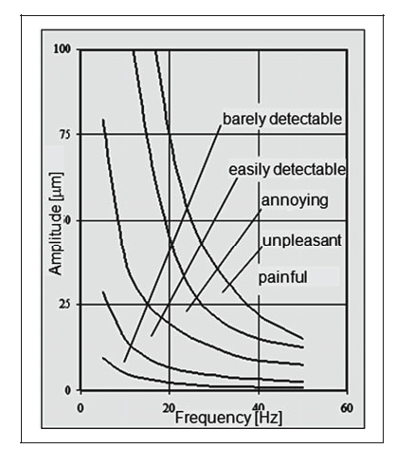

Figure Human perception range (vertical motion) [6]

As Figure 12 depicts, passengers’ comfort heavily depends on car’s frequency and vertical amplitude. In low frequency(low speed), the discomfort is mainly dependent on vehicle’s amplitude, but in high frequency(high speed), passengers are much sensible to the amplitude, even less than 20 mm.

In summary, in round 1, the short-term and long-term probability distribution on road profile are discussed and they are subordinated to Gaussian distribution and Rayleigh distribution, respectively. When it comes to the Round 5, the main points are emphasis on peak values during short-term and long-term travelling process. On the one hand, whenever in round 1 or round 5, the probability distribution either with road profile or with various wave peaks is subordinated to Gaussian distribution in short-term process. On the other hand, from the view of lifetime, the probability is subordinated to Rayleigh distribution, whenever the rainflow analysis method is applied in different road types or the probability distribution of long-term road situation. Possibly, the probability of maximum points also represented as peak value can be captured more times when travelling time is enough long (equal to different road situation). Now that the probability distribution of road profile is subordinated to Rayleigh distribution, if we only consider those peak values, they seem also be subordinated to the same distribution with road profile.

Reference journal

[1] Bruscella, B., Rouillard, V., and Sek, M. A. (1999). “Analysis of road profiles.”J. Transp. Engrg., ASCE, 125(1), 55–59.

[2] Rouillard V, Sek M A, Perry T. Analysis and Simulation of Road Profiles[J]. Journal of Transportation Engineering, 1996, 122(3):241-245.

[3] Y. Qin, M. Dong, F. Zhao, R. Langari and L. Gu, "Road profile classification for vehicle semi-active suspension system based on Adaptive Neuro-Fuzzy Inference System," 2015 54th IEEE Conference on Decision and Control (CDC), Osaka, 2015, pp. 1533-1538, doi: 10.1109/CDC.2015.7402428

[4] Cherneva, Z. & Soares, C. (2014). Time-frequency analysis of the sea state with the Andrea freak wave. Natural Hazards and Earth System Sciences, 14(12), p. 3143. doi:10.5194/nhess-14-3143-2014

[5] Kropáč, O. & Múčka, P. (2008). Deterioration Model of Longitudinal Road Unevenness Based on its Power Spectral Density Indices. Road Materials and Pavement Design, 9(3), pp. 389-420. doi:10.1080/14680629.2008.9690125

[6] Heißing B., Ersoy M. (2011) Ride Comfort and NVH. In: Heißing B., Ersoy M. (eds) Chassis Handbook. Vieweg+Teubner.

Supplement

Some contents with mathematic formula in dynamic feedback in MyCourse:

|  |  |
| --- | --- |
| number | expression |
| 1 | Continuous and discrete probability distributions; |
| 2 | random vibrations; |
| 3 | fourier-transformation of random vibrations; |
| 4 | single degree of freedom system in frequency domain; |
| 5 | gaussian signal in time domain; |
| 6 | peak and extreme value statistics; |

1. Formula

cumulative probability distribution function (CDF)

if P(x) is the distribution function of the discrete random variable X, then we can get $P\{X=x_{i}\}$ which is the probability of one point, that is

$$P\{X=x_{i}\} = p_{i}≥0, i =0,1,2...$$

$x_{i}$ is one point on the horizontal axis, $p_{i}$ is the probability at one point, i is random natural number

Then the cumulative distribution function is

$$P(x) = P\{X≤x\}=\sum_{x≤x_{i}}{P\{X=x_{i}\}=\sum_{x≤x_{i}}{p_{i}}}$$

if P(x) is the distribution function of the continuous random variable X, then we can get $P(x)$ which is the probability distribution function, that is

$$P(x) = Pr[X≤x] = \int_{-∞}^{x}{p(x)dx}$$

Where $p(x)$ is probability density function. p(x) is different with different distributions.

1. Formula

|  |  |
| --- | --- |
| Type | Formula |
| Free vibration | f = 0 |
| Forced vibration | f = f(t) (exponential function, logarithmic function and so on) |
| Harmonic excitation force | f = f(t) = u(t)+ $u_{p}(t)=$ $e^{-ξω_{e}t}\left(a_{1}cos\left(ω_{d}t\right)+a2sin\left(ω_{d}t\right)\right)+asin\left(ωt-φ\right)$ (trigonometric function) |

1. Formula

Set a model of m-c-k system, and the formula is

$$m\ddot{x}+d\dot{x}+cx=P(t)$$

P(t) is external loading;

m is the mass;

d is coefficient of damper;

c is the stiffness of spring;

$x is displacement, \dot{x} and \ddot{x} are its first derivative and second derivative.$

With Fourier transformation to express the loading in frequency domain is that

$$P(t) = \frac{1}{2π}\int_{-∞}^{+∞}{A_{P}(ω)e^{iωt}dω}$$

1. Formula

Using fourier transformation to input, we can get equilibrium equation in frequency domain,

$$x(t)= \frac{1}{2π}\int_{-∞}^{+∞}{A_{x}(ω)e^{iωt}dω}$$

$$\dot{x(t)}= \frac{1}{2π}\int_{-∞}^{+∞}{A_{x}(ω)iωe^{iωt}dω}$$

$$\ddot{x(t)}= -\frac{1}{2π}\int_{-∞}^{+∞}{A_{x}(ω)ω^{2}e^{iωt}dω}$$

so, the formula about m-c-k system can be expressed by variable $ω$

$$m\ddot{x}+d\dot{x}+cx=-m\frac{1}{2π}\int_{-∞}^{+∞}{A_{x}(ω)ω^{2}e^{iωt}dω}+d \frac{1}{2π}\int_{-∞}^{+∞}{A_{x}(ω)iωe^{iωt}dω}+c\frac{1}{2π}\int_{-∞}^{+∞}{A_{x}(ω)e^{iωt}dω} = \frac{1}{2π}\int_{-∞}^{+∞}{A_{P}(ω)e^{iωt}dω}$$

1. Formula

Gaussian signal is that the probability distribution x is subordinated to gaussian distribution with two variables mean value and standard deviation.

$$p(x) = \frac{1}{σ\sqrt{2π}}e^{-{(x-μ)}^{2}/2σ^{2}}$$

$$P(x) = \frac{1}{σ\sqrt{2π}}\int_{-∞}^{x}{e^{-{(x-μ)}^{2}/2σ^{2}}}dx$$

p(x) is the probability distribution function; P(x) is its distribution function

$μ$ is mean value of p(x), $σ$ is standard deviation of p(x)

1. Formula

Extreme value of gaussian process,

$$\overline{z}=\sqrt{2ln(\frac{T}{2π}{(60)}^{2}\sqrt{\frac{m_{2}}{m_{0}}})\sqrt{m_{0}}}$$

$\overline{z}$ is mean extreme value;

T is time history of one period;

$m_{0}$ is the mean value of square of system response elevation;

$m_{2}$ is the mean value of square of first order derivation of system response elevation;

For peak of gaussian process

$$p_{p}(a)=\frac{a}{σ_{y}^{2}}e^{-a^{2}/2σ_{y}^{2}}$$

$p_{p}(a)$ is the distribution of peak;

a is peak value;

$σ_{y}^{2}$ is equal to E[y^2].